Trenton Walty

CS330

2/19/23

Project Written explanation

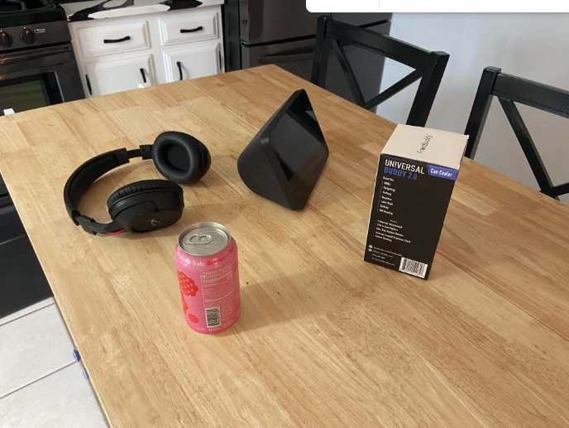

When I was trying to figure out what I wanted to design in my 3D scene I walked around my house for a range of handheld items. With them being handheld, they were easier to relocate and mentally prepare myself to design them. When I was deciding on these four items, I wanted to first get something simple like the universal buddy box and then find items where I could work up the difficulty. The second item I decided on due to difficulty was the Amazon Alexa. I thought this would be an interesting piece to design because of its odd angles and shape. The soda can was an interesting piece to design due to the ability to create one small piece and then revolving the piece in a circle with the use of an if statement. The most difficult piece to design was the headset due to its multiple shapes that went into making it. To minimize the amount of code I used to recreate these pieces I used the soda cans vertices and resized and located them to be used as the headset’s headphones. You can navigate the 3D scene with the use of the mouse and alt key. If you hold the alt key and click the left mouse button you can rotate around the scene and if you use the middle button while holding the alt key, you can pan across the scene. If any visual issues are run into you can hit the F key to reset the camera to its original position.